Grumpy Frogs Table Tennis

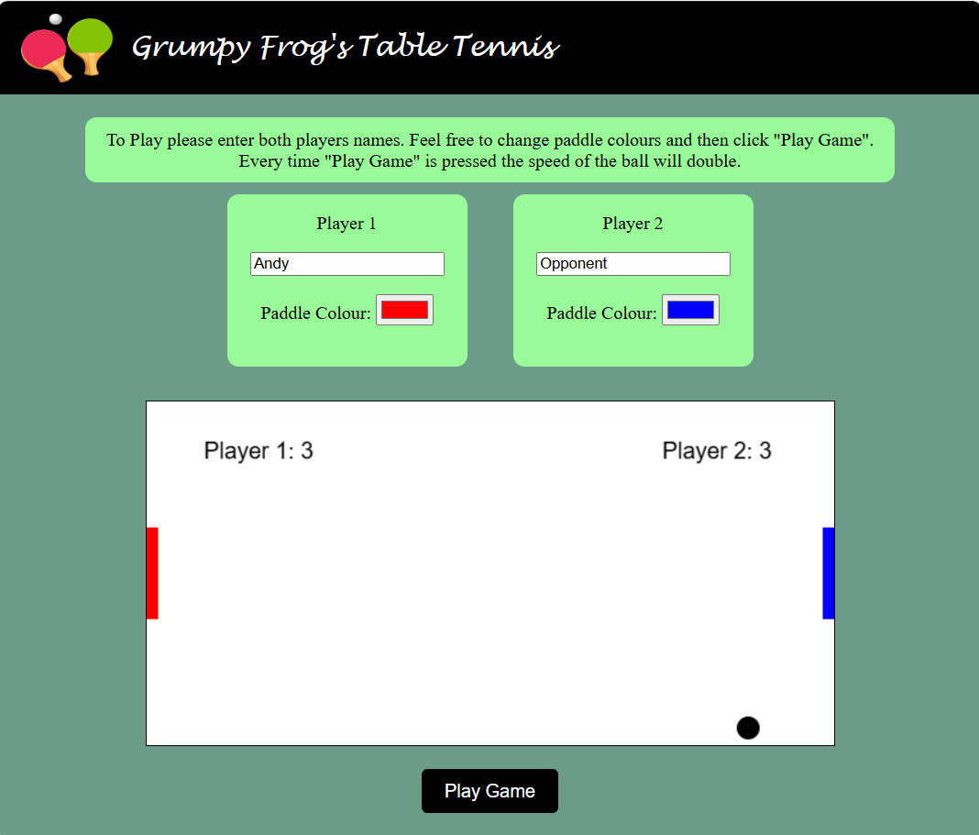

TABLE OF CONTENTS
- Project Goal
- User Experience
- Features
- How to Play
- Design Choice
- Wire Frame
- Technologies Used
- Validation & Testing
- Bugs
- Future Improvements
- Deployment

Project Goal
Grumpy Frogs Table Tennis is a light hearted and engaging 2-player game inspired by the iconic arcade classic, Pong. Each player controls a paddle and competes to score points by skill-fully hitting the ball past their opponent's paddle. Designed for fun and simplicity, this game brings a modern twist to a retro favourite, making it enjoyable for players of all ages.

User Experience
This game is crafted to be accessible and enjoyable for players of all ages. With its simple mechanics and intuitive controls, Grumpy Frogs Table Tennis ensures a fun and engaging experience for everyone, from casual gamers to those seeking a nostalgic throwback. Easy to play, the game offers instant entertainment while maintaining a satisfying level of challenge.

Features
- Two-Player Gameplay: Enjoy competitive matches with a friend, each controlling a paddle in fast-paced table tennis action.
- Customizable Player Names: Personalize the experience by entering player names before each game. Also checks that the user inputs letter only for their name.
- Easy-to-Learn Controls: Simple and responsive controls ensure anyone can jump right in and start playing without a learning curve.
- Score Tracking: Real-time score display keeps track of points, adding excitement as the game progresses.
- Dynamic Difficulty: As the game continues, and the start game button is clicked, the ball speed increases, adding an extra layer of challenge for both players.
- Clean & Minimalist Interface: A sleek, uncluttered design keeps the focus on the gameplay for a smooth and enjoyable experience.

How to Play
No downloads or installations are needed, simply open the game in a browser. Players enter their names, can change paddle colours and press the "Start Game" button to begin.
- Left Paddle Controls: Move up using W and down using S.
- Right Paddle Controls: Move up with the Up Arrow key and down with the Down Arrow key.
With the easy-to-use controls, players can immediately jump into a fast-paced, competitive match!

Design Choice
The game's design follows a clean, minimalist approach, ensuring that players can focus entirely on the gameplay without distractions. By keeping the background simple and uncluttered, the game maintains its core functionality while delivering a streamlined and engaging experience that feels intuitive and visually pleasing.

Wire Frame
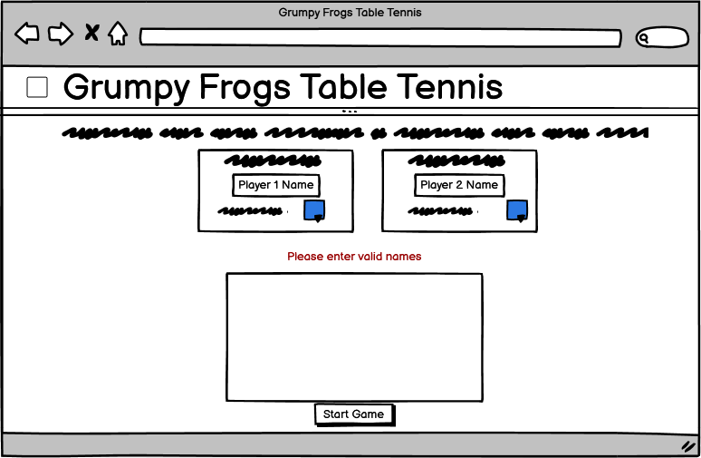

Technologies Used
Frameworks & Tools
- HTML
- CSS
- JS
- GitHub
- Sublime Text
- Balsamic Wireframes
- ChatGPT
- Microsoft Edge
- Free Background Remover - https://www.remove.bg/

Validation & Testing
HTML
I ran my HTML code through W3C Markup Validator
CSS
I ran my CSS code through W3C Jigsaw Validator
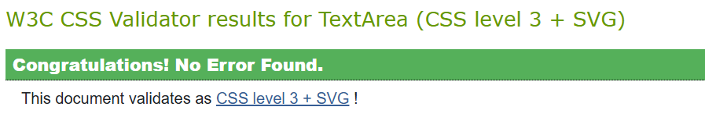
JS
I ran my CSS code through JSLint and have an error
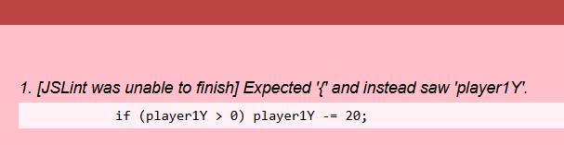
Test | User Requirement Addressed | Expected Result | Actual Result | Pass / Fail | Date | Corrective Action
Title | Title at top left | Title at top left | Title is top left | Pass | 21/10/24 | None Needed
Enter Names | Enter names with just letters | A warning if name not just letter | Gives warning when it is not only letters | Pass | 21/10/24 | None Needed
Simple Instructions | Simple Instructions Displayed | Simple Instructions Displayed | Simple Instructions Displayed at Top | Pass | 21/10/24 | None Needed
Increased Difficulty | Able to increase difficulty | Difficulty to increase | Ball speed doubles after start game is pressed again | Pass | 21/10/24 | None Needed
Score | Have Score | Score to be displayed | Score is display upon game start | Pass | 21/10/24 | None Needed
Change Player Colour | Change Player Colour | Player paddle to change colour | Player is able to change their colour | Pass | 21/10/24 | None Needed

Bugs
Although my code went through the HTML and CSS Validators, I did get an error on the JSLint Checker. I have revised this code and cannot work out what the issue is, although I will keep trying to solve the issue.

Future Improvements
- Fix JS error
- Have a difficult selector.
- Start Game button will become Reset button when playing, then when reset, will go back to being the Start Game button.
- Score Leader Board
- Make it more responsive

Deployment

I have uploaded my site to GitHub, in the future I will enable users to find the game within my portfolio website.

